|  |
| --- |
| Fontys University of applied sciences |
| Design Document |
| Version I |
|  |
|  |
|  |

*Rosen Danev*

*Preslav Gerchev*

*Dimitar Vikentiev*

*Monica Stoica*

Table of Contents

Introduction 3

Class diagram 4

# Introduction

The purpose of this document is to identify the design of our network software system. The system’s structure will be defined using the Unified Modeling Language .

The first chapter will be represented by a class diagram and the description of each class’ members such as fields, properties and methods. The class diagram provides an overview of the software system by describing the classes inside the system and the relationship between them.

Moreover, to have a better understanding of how the objects interract with others in a paricular scenario (use-case), few sequance diagrams will be explained.

# Class diagram

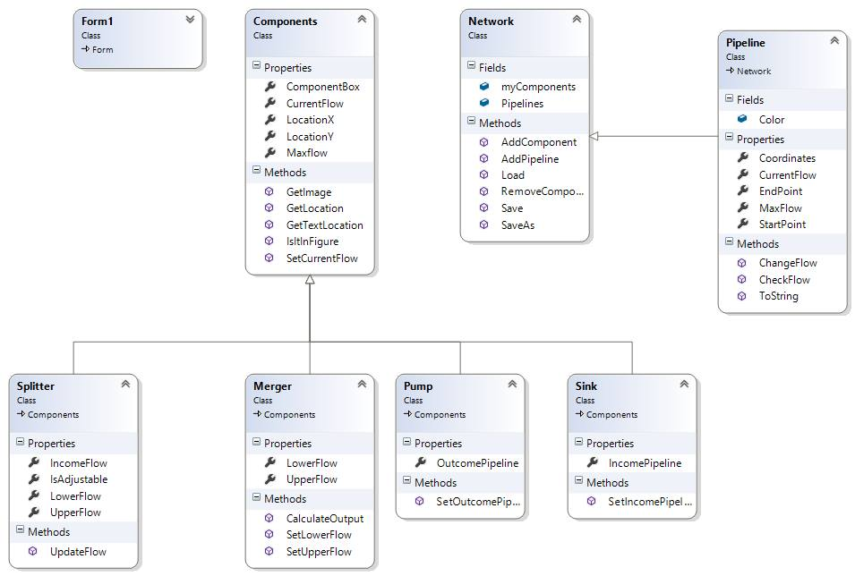

Below you can find a description of the fields, properties and methods used in our class diagram.

***Component –***The base abstract class, parent toall the components except Pipeline. Contains the common properties and methods.

ComponentBox – returns the Rectangle that contains the component (and the image). Used to check if it intersects with other components when they are added to our network.

CurrentFlow – The current flow of the component. Default value is 0.

LocationX –The X coordinate of the top-left corner of the component. Instantiated in the constructor.

LocationY – The Y coordinate of the top-left corner of the component. Instantiated in the constructor.

MaxFlow – The max flow of the component. Instantiated in the constructor.

*GetImage() –* returns the image that will be used for every component. It’s an abstract method and must be overridden in every derived class with the path to the corresponding picture (they are saved in Resources and can be accessed via Properties.Resources.NameOfTheComponent).

GetLocation() – returns a Point,created off the coordinates of LocationX and LocationY. Used to draw the image on this Point.

GetTextLocation() – returns a Point where the text that contains the current flow will be drawn.

IsInFigure() – returns a Boolean, used to verify if there any other figures that intersect with the componentBox.

SetCurrentFlow() – sets the current flow of the component.

**Splitter –** A derived class from ***Component***.

IncomeFlow- The flow coming from the pipeline,connected to the Splitter.

IsAdjustable – returns a Boolean,if the splitter is adjustable or not.

UpperFlow- returns the flow that goes through the upper part of the splitter.

LowerFlow – returns the flow that goes through the lower part of the splitter.

UpdateFlow()- used to calculate the Upper and Lower flow based on given percentages(if the splitter is adjustable).

**Merger –**A derived class from ***Component.***

LowerFlow – the flow coming through the lower part of the merger.

UpperFlow – the flow coming through the upper part of the merger.

SetLowerFlow()- used to set the lower flow.

SetUpperFlow() – used to set the upper flow.

CalculateOutput() – calculates the total output of the merger.

Pump – A derived class from ***Component.***

OutcomePipeline – a property of type Pipeline that references to the pipeline that comes from that pump.

SetOutcomePipeline() – sets the outcoming pipeline.

Sink – A derived class from ***Component.***

IncomePipeline – a property of type Pipeline that references to the pipeline that comes into that pump.

SetIncomePipeline() – sets the incoming pipeline.

**Pipeline**

Color – used to mark the color of the pipe. Red if the current flow is equal to the max flow.

Coordinates – a list of Points that contains all the points that are in between the source and the destination of the pipeline. Used when the pipeline is being drawn.

CurrentFlow – the current flow of the pipeline.

MaxFlow- the max flow of the pipeline.

StartPoint- the point where the pipeline starts.

EndPoint – the point where the pipeline ends.

ChangeFlow() – used to change the CurrentFlow.

CheckFlow() – used to check if the current flow does not exceed the max flow or if it is equal( and change the color of the pipeline accordingly).

**Network**

myComponents – a list of all components that are currently located on the picturebox.

Pipelines – a list of all piplines that are currently located on the picturebox.

AddComponent() – adds a component to the list.

AddPipeline() – adds a pipeline to the list.

RemoveComponent() – removes a component from the list.

Load() – loads a file for the user.

SaveAs() – saves the file for the user for future use.

Save() – automatically saves the file if it has already been saved once before.